Christian Garcia

Michael Quang

ELEN 164 Lab

13 October 2021

Lab 4: Rectifiers

Preparation

Question: If the coupling coefficient is 0.99 what do you think that implies?

This indicates that the transformer is near ideal. This means that the voltage can be stepped up or down without minimal losses.

Question: What does this ideal model state about the behavior of the diode?

It states that there is no forward voltage, that there is a minimal resistance of 1 mohms when the diode is on. In the case when the diode is on, all current should be allowed to pass through the diode. A resistance of 100 MegaOhms when the diode is off. This is to simulate a very large resistance such that very little current can pass through the diode when it is off.

**Part 1: Half Wave Rectifier**

**Section 1: Resistive load**

**Circuit:**

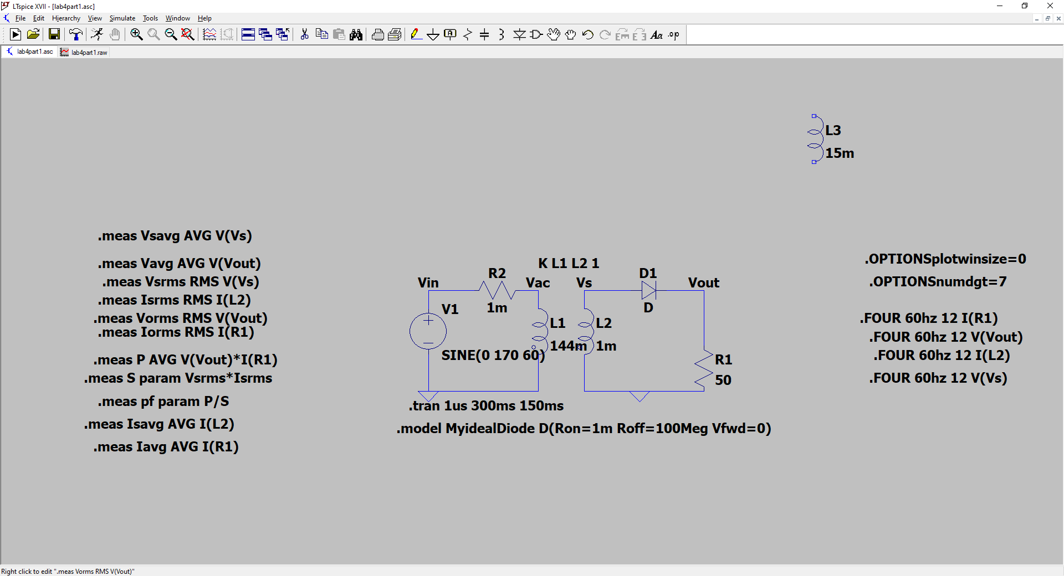

Question: What do the L1, L2 values provide in turns ratio?

It provides a turns ratio of 12:1 turns.

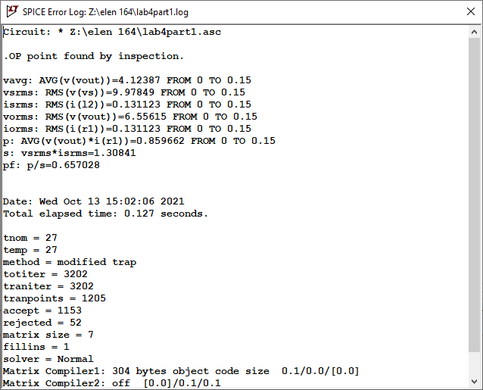

Observations and Calculations:

|  | Average | RMS | Peak | FFTDCValue | FFTn = 1 | FFTn = 2 | FFTn = 4 | FFTn = 6 | FFTn = 8 | FFTn = 10 | FFTn = 12 |
| --- | --- | --- | --- | --- | --- | --- | --- | --- | --- | --- | --- |
| OutputVoltage | 4.12387 | 6.55615 | 13.316277 | 4.12381 | 6.553e+00 | 2.935e+00 | 5.480e-01 | 2.105e-01 | 1.006e-01 | 5.273e-02 | 2.882e-02 |
| LoadCurrent | 0.0824774 | 0.131123 | 266.33654mA | 0.0824762 | 1.311e-01 | 5.869e-02 | 1.096e-02 | 4.211e-03 | 2.011e-03 | 1.055e-03 | 5.764e-04 |
| SourceVoltage | -0.00159726 | 9.97849 | 14.11883 V | -0.00338207 | 1.411e+01 | 4.548e-03 | 1.256e-03 | 3.079e-03 | 3.824e-03 | 2.570e-03 | 1.519e-03 |
| SourceCurrent | -0.0824774 | 0.131123 | -98.701526pA | -0.0824762 | 1.311e-01 | 5.869e-02 | 1.096e-02 | 4.211e-03 | 2.011e-03 | 1.055e-03 | 5.764e-04 |

Observations to be noted for the report:

* What do you notice with the waveforms? Describe what is happening when the AC signal is positive and when the signal is negative.
  + A portion of the signal is lost. In the positive half cycly, the voltage is shown at the output. However, at the negative half cycle, that output signal is lost.
* What are important parameters to consider when picking a diode?
  + Important to make sure that the diode is as close to ideal as possible. This means that when the diode is on, very little resistance is observed, and when the diode is off, the resistance must be at a very large value.
* What is ideal power factor possible for this rectifier. What power factor was obtained. Are these the same. Explain why or why not?
  + Ideal Power factor for this system is 0.707. We obtained a power factor of 0.657. These are not the same values, however, this is a valid power factor for the system. With a half wave rectifier, the maximum power factor is 0.707. This is a limitation as a result of losing a portion of the output signal.
* Draw a graph showing the frequency content of the output showing the harmonics.

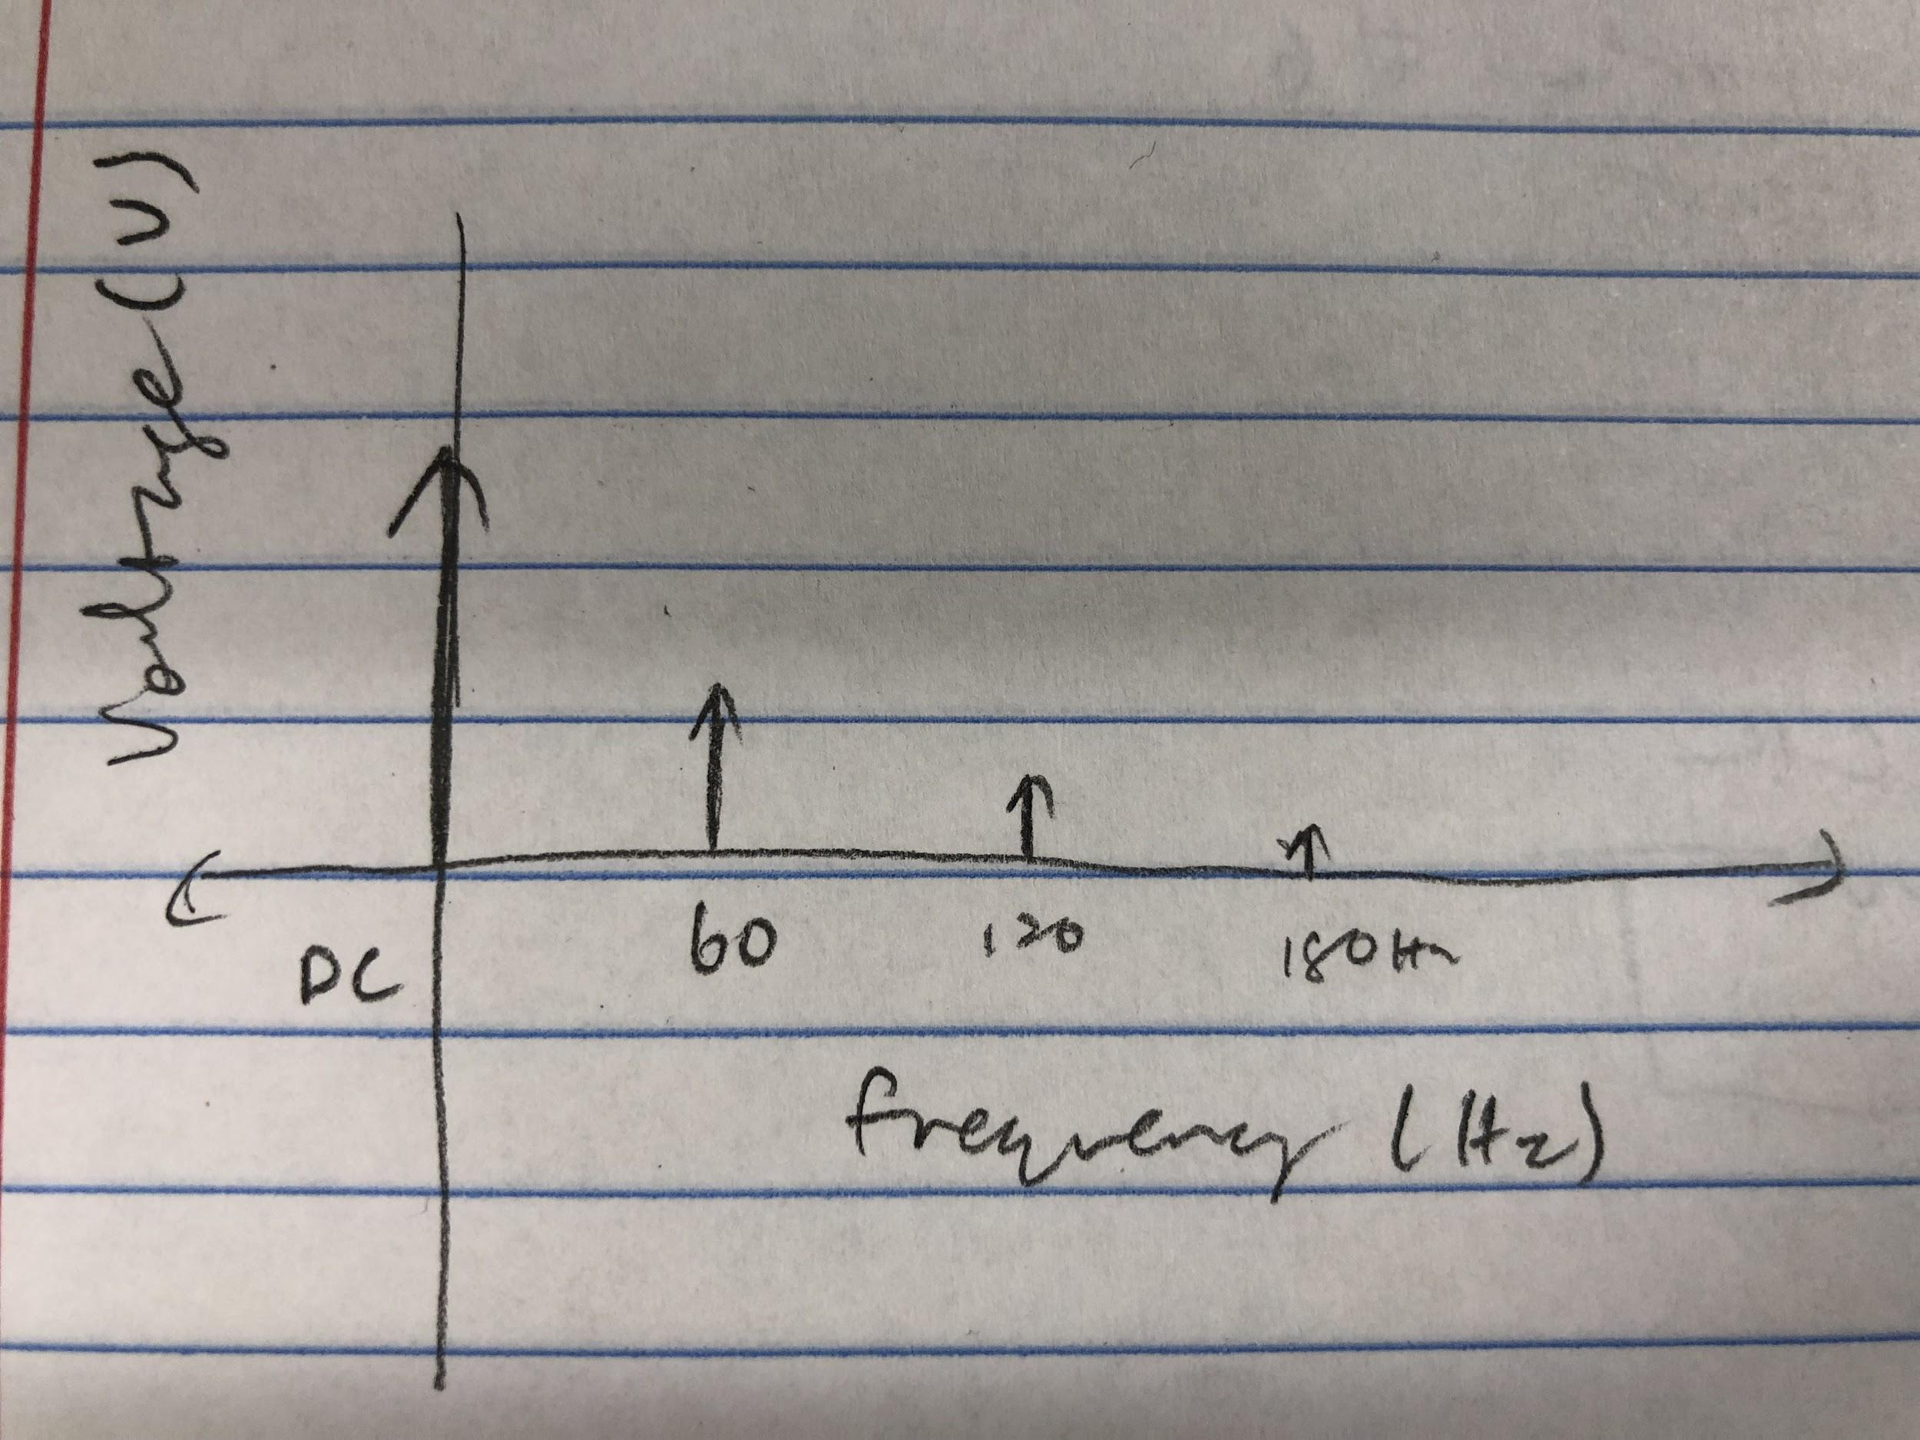

* Take screen shot of your circuit and all waveforms that you think are necessary to support your claims above

Plots

Output Voltage Graph

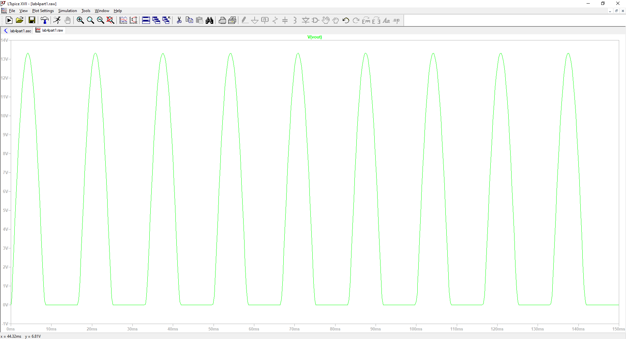

Output current Graph

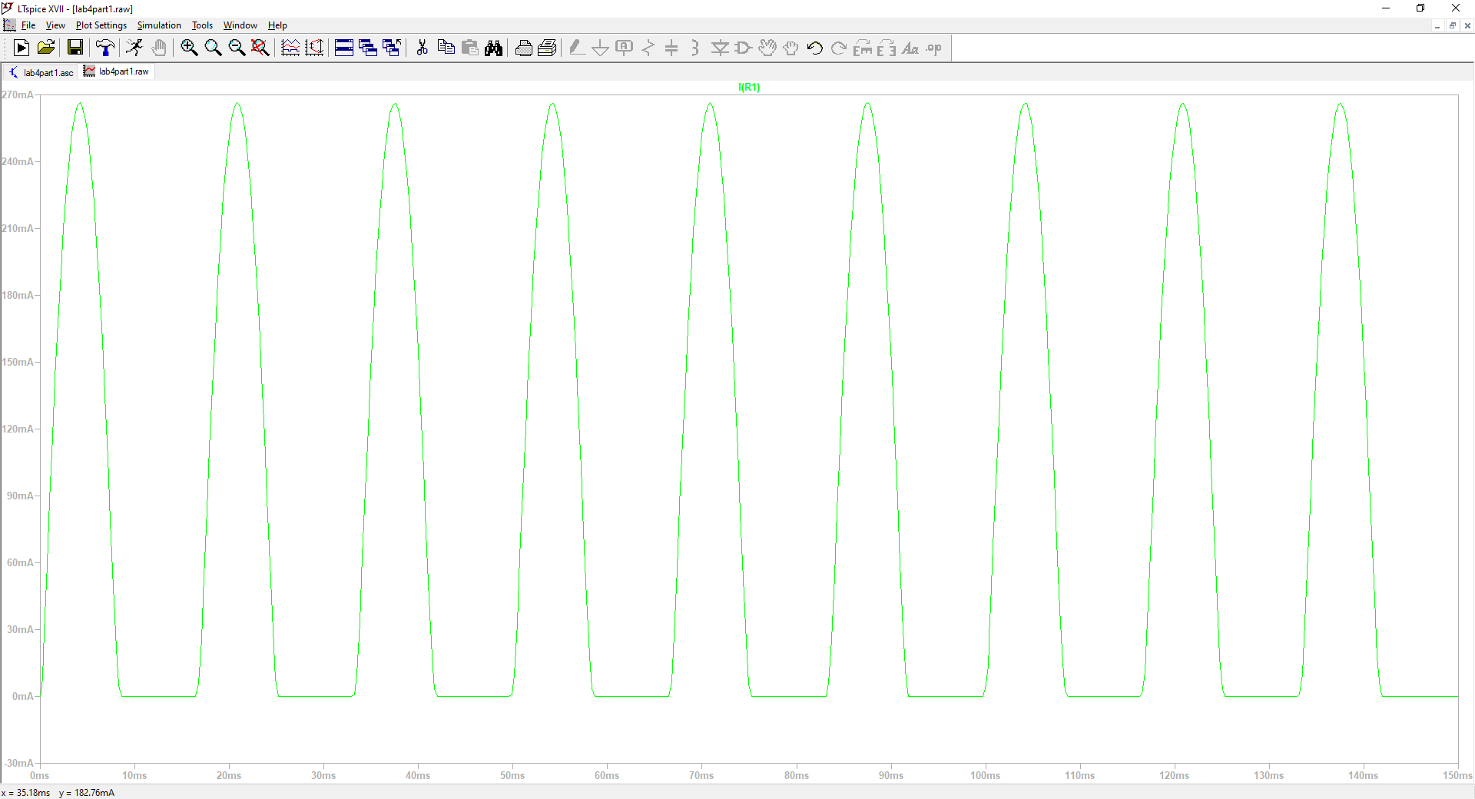

Source Voltage Graph

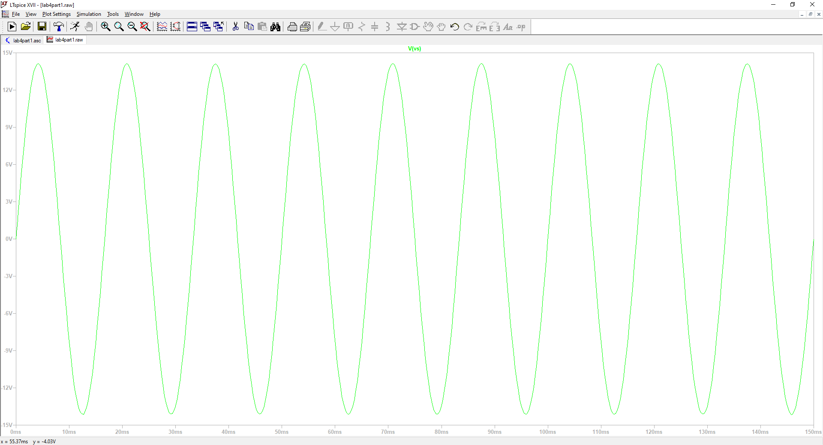

Source Current Graph

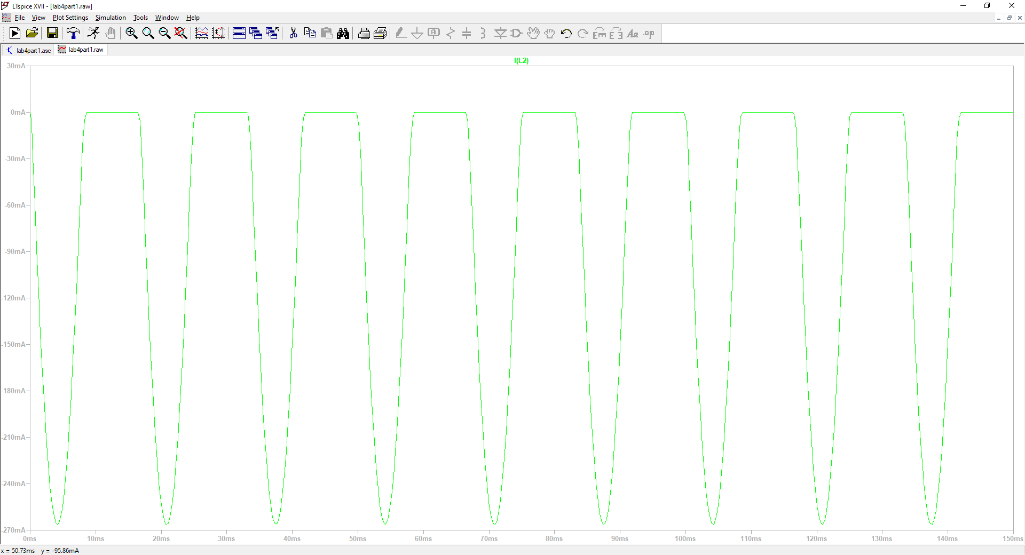

Output voltage FFT

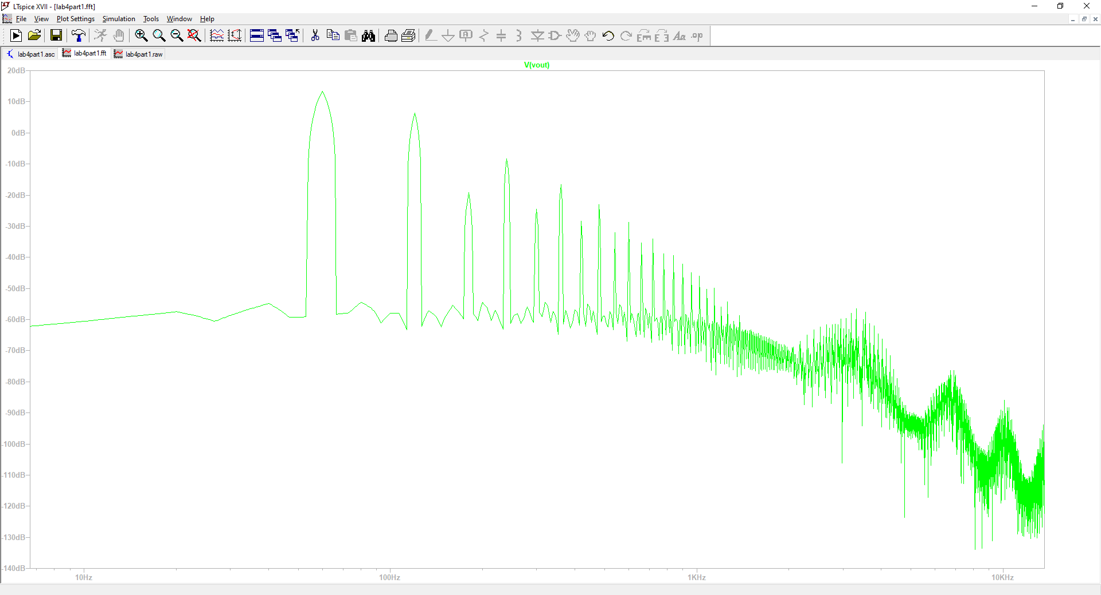

Output Current FFT

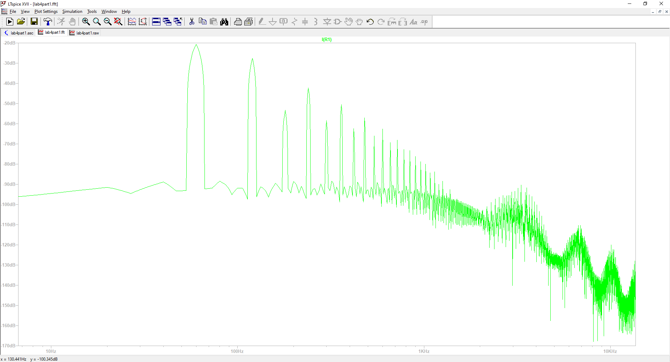

**Section 2: Resistive Load with Non-Ideal Diode**

**Circuit:**

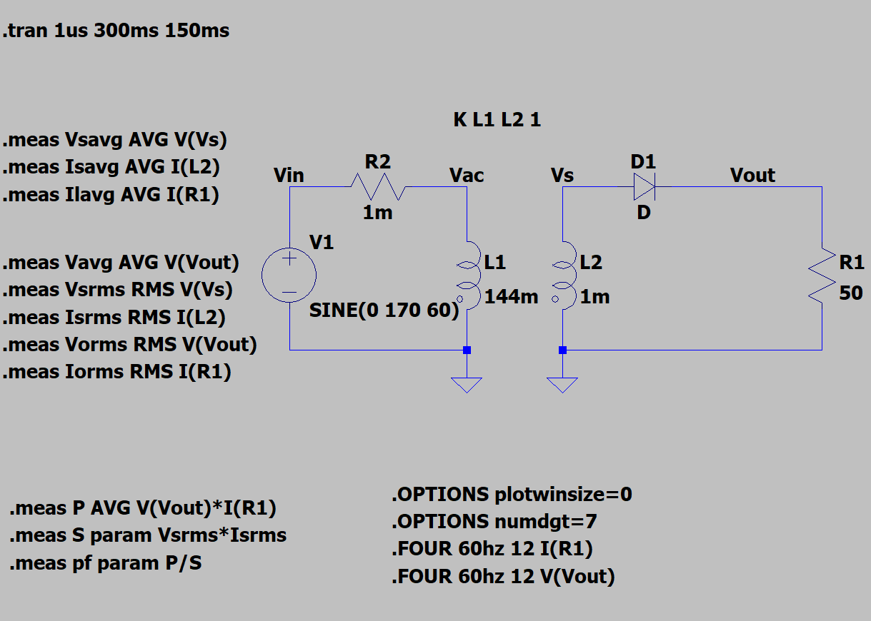

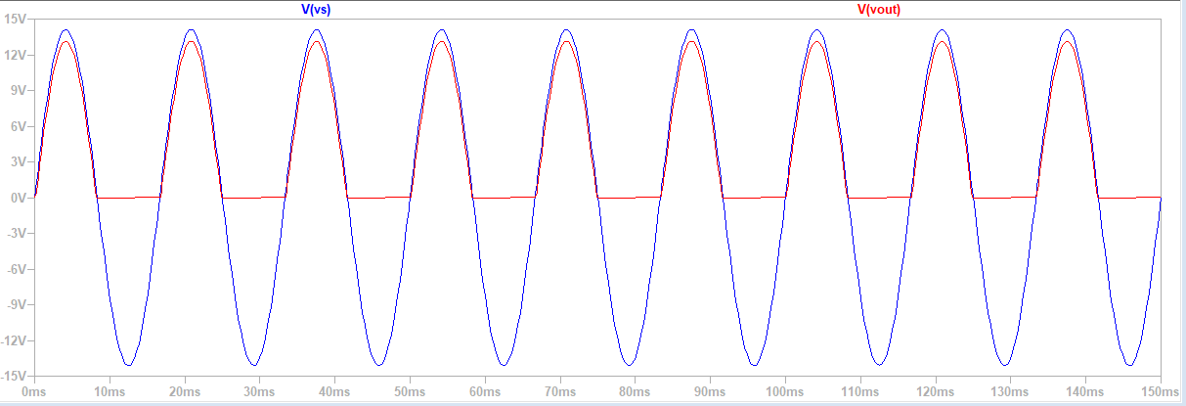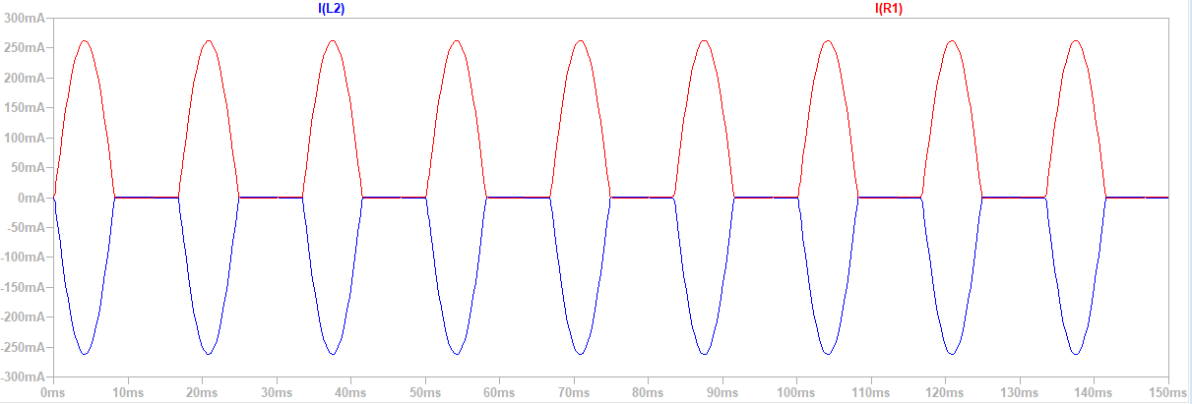

|  | Avg | RMS | Peak | FFT  DC | FFT  n=1 | FFT  n=2 | FFT  n=4 | FFT  n=6 | FFT  n=8 | FFT  n=10 | FFT  n=12 | Unit |
| --- | --- | --- | --- | --- | --- | --- | --- | --- | --- | --- | --- | --- |
| Output Voltage | 4.052 | 6.462 | 13.12811 | 4.05186 | 6.459 | 2.92 | 0.5647 | 0.03582 | 0.01882 | 0.0112 | 0.007174 | V |
| Load Current | 0.081 | 0.129 | 0.262617 | n/a | n/a | n/a | n/a | n/a | n/a | n/a | n/a | A |
| Source  Voltage | 0.0001 | 9.977 | 14.11385 | n/a | n/a | n/a | n/a | n/a | n/a | n/a | n/a | V |
| Source Current | -0.081 | 0.129 | -0.262617 | n/a | n/a | n/a | n/a | n/a | n/a | n/a | n/a | A |

Power Factor = 0.647722

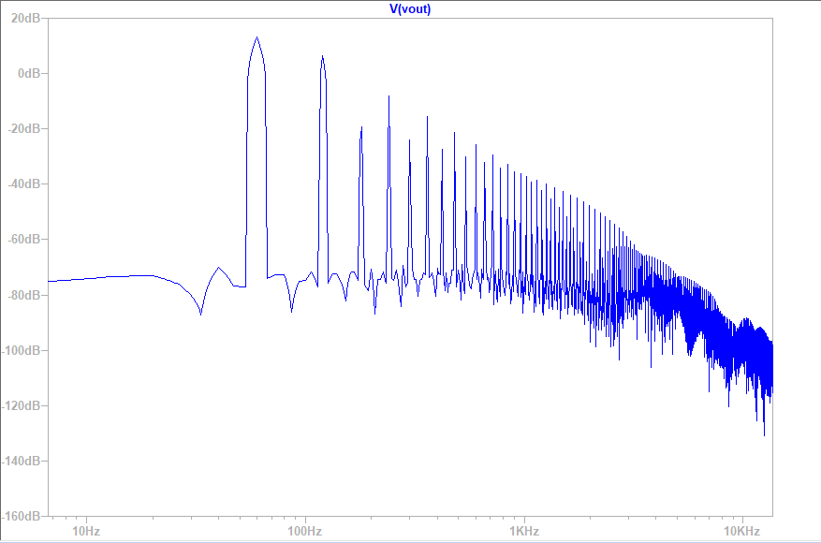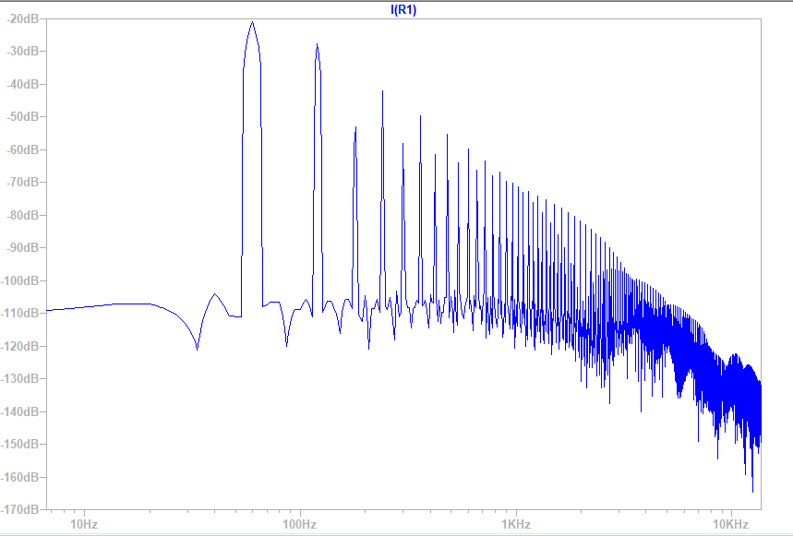

Questions:

1. What do you notice with the waveforms? Describe what is happening when the AC signal is positive and when the signal is negative.
   1. I noticed that we have built a half wave rectifier. I know this because when my AC signal is positive we have an output signal almost to the same peak value, but then with a negative AC signal we have an output signal of 0.
2. What are important parameters to consider when picking a diode?
   1. Some important parameters to consider when picking a diode are voltage drop and current ratings. Voltage drop is important because we want to be able to maintain good efficiency in a circuit and current ratings are important to make sure that the circuit will function properly.
3. What is the ideal power factor possible for this rectifier? What power factor was obtained. Are these the same? Explain why or why not?
   1. The ideal power factor for a half wave rectifier is 0.707. We obtained a power factor of 0.648. They aren’t the same but are very close to each other which means that our rectifier was very efficient. The discrepancies can come from the fact that the diode is no longer ideal. Because of this there will be a voltage drop affecting our power factor.
4. Why is the output signal peak lower than the input signal peak?
   1. The output signal is lower because of the voltage drop that comes from the diode no longer being ideal.
5. Why is there a very small non-conduction time to the output when the input voltage is positive but small?
   1. There is a very small non-conductive time because the diode is not ideal. Because of this, there will be a small time frame where the diode will not conduct voltage to the output. Only after the input voltage is much greater than the voltage required for the diode to turn on will conduction be seen at the output.
6. Is the average output voltage as expected? Explain why or why not.
   1. Yes it is expected because we know that the source average voltage is 0 due to its sinusoidal nature. Then when looking at the rms voltage of the input, at 9V, we look at the output average 4.05. Since we know that it is only seeing the positive half, it should be half of the output so it makes sense.
7. Is the power factor as expected? Explain why or why not.
   1. Since an ideal power factor is 0.7 and our power factor is 0.648 yes this is expected. The change comes from the voltage drop in the non-ideal diode.

**Section 3: RC Load**

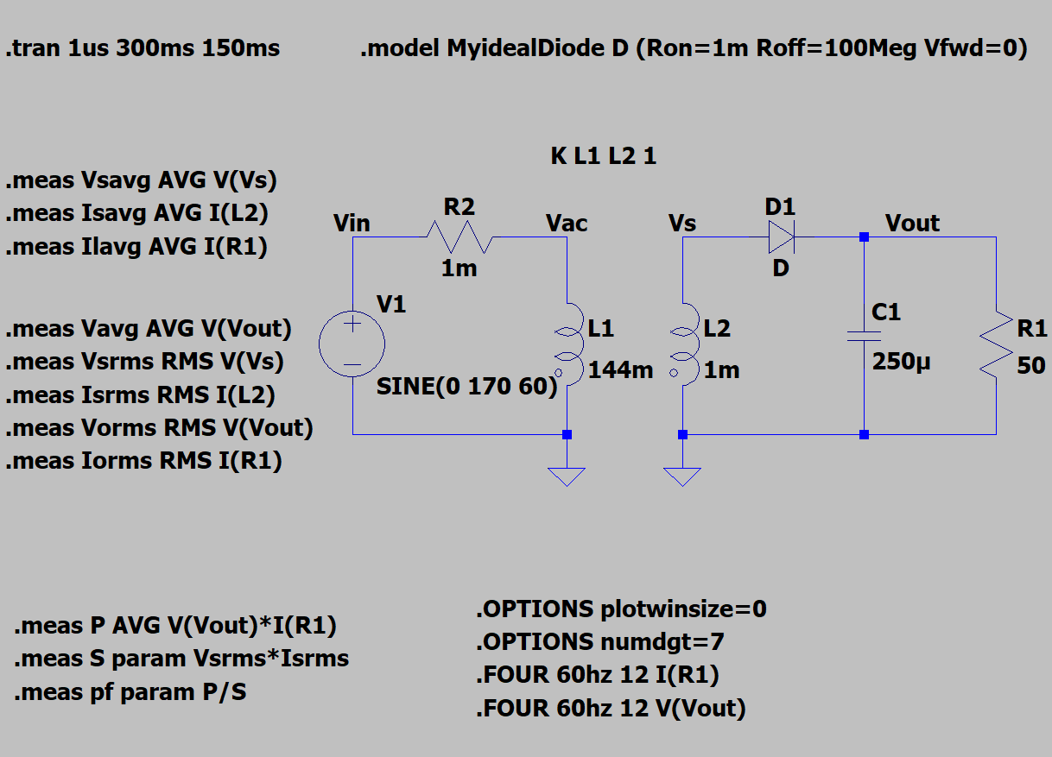

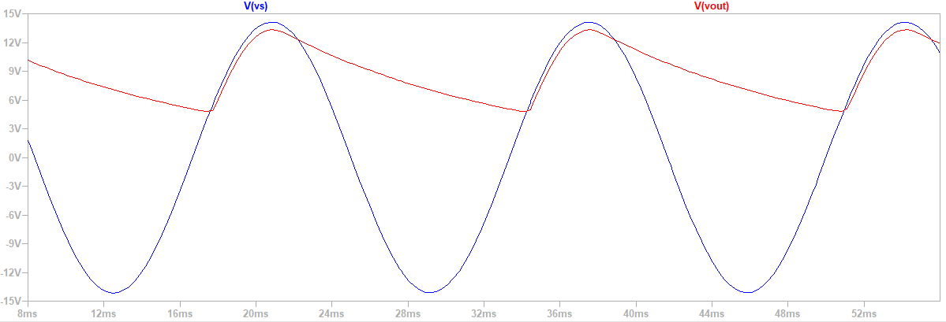

| C = 250uF | Average | RMS | Peak | Voltage Ripple | Units |
| --- | --- | --- | --- | --- | --- |
| Output Voltage | 8.73694 | 9.14108 | 13.316521 | 8.5152075 | V |

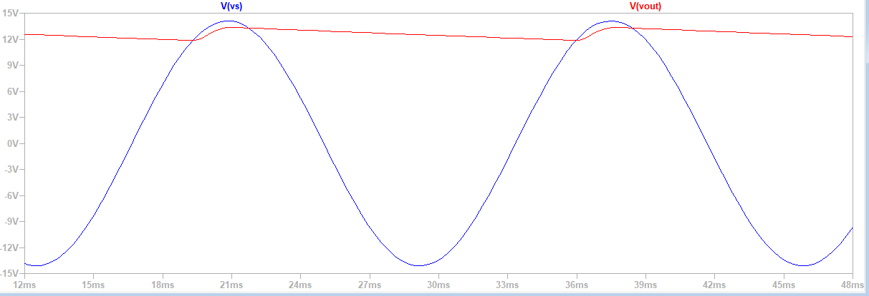

| C = 2.5mF | Average | RMS | Peak | Voltage Ripple | Units |
| --- | --- | --- | --- | --- | --- |
| Output Voltage | 12.611 | 12.6189 | 13.3519 | 1.4689095 | V |

1. What do you notice with the waveform?
   1. In these waveforms we can see how our output greatly improved from part 2. We can see a small ripple on our output graph. This is due to the filter that is created from the capacitor we added in the circuit.
2. Describe how the addition of the capacitor affects the output signal.
   1. The capacitor acts as a filter. This is why we don’t see the output voltage below a certain value. That portion of the waveform gets filtered out which creates the ripple we see in the graph
3. What happens to the output signal if the capacitor were to increase?
   1. We can see from our two different graphs that with a larger capacitance value the filter improves and we see a smaller ripple value.
4. What if the resistor were to decrease?
   1. If the resistor were to decrease we would see a worse filter with a greater ripple voltage. This is because of the inverse relationship between the resistor and ripple voltage.
5. What is the ripple voltage seen at the output?
   1. With the 250uF Capacitor we see a ripple of 8.515V and with the 2.5mF Capacitor we see a ripple of 1.469V.

**Section 4: RL Load**

**Circuit:**

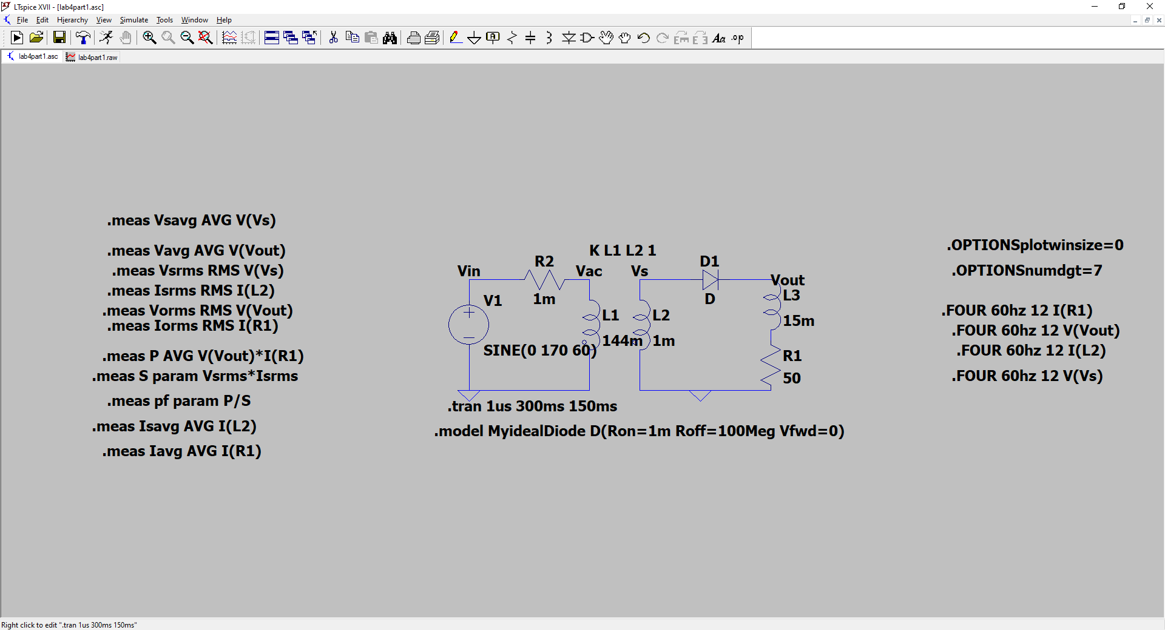

|  | Average | RMS | Peak | FFTDCValue | FFTn = 1 | FFTn = 2 | FFTn = 4 | FFTn = 6 | FFTn = 8 | FFTn = 10 | FFTn = 12 |
| --- | --- | --- | --- | --- | --- | --- | --- | --- | --- | --- | --- |
| OutputVoltage | 4.10065 | 6.55603 | 13.291844 | 4.10821 | 6.552e+00 | 2.967e+00 | 5.788e-01 | 2.406e-01 | 1.279e-01 | 7.801e-02 | 5.052e-02 |
| LoadCurrent | 0.0819164 | 0.130282 | 264.34147mA | - | - | - | - | - | - | - | - |
| SourceVoltage | -0.00138444 | 9.97852 | 14.11883 V | - | - | - | - | - | - | - | - |
| SourceCurrent | -0.0819164 | 0.130282 | -98.701526pA | - | - | - | - | - | - | - | - |

Voltage across Inductor

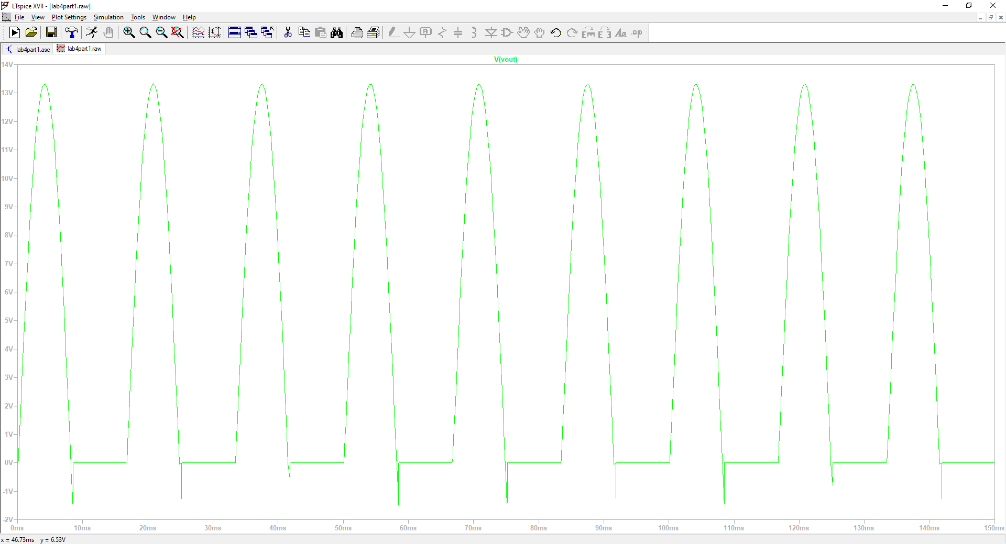

Voltage across Resistor

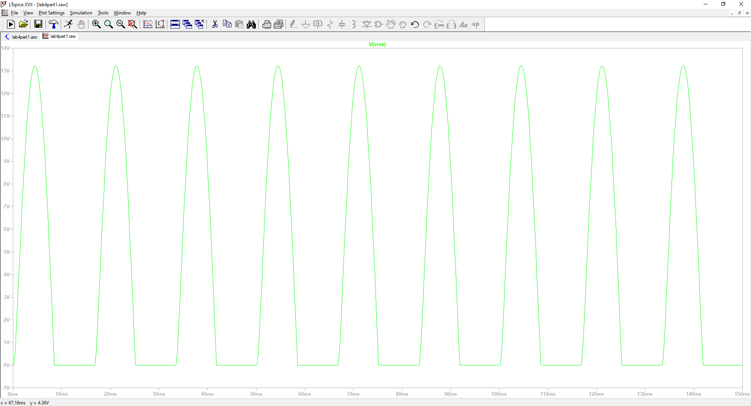

Power Factor: 0.6526

* What would happen to the output signal if the inductor were to increase?
  + That small dip in the output voltage will increase, and there will be a greater variance in output voltage at those dips.
* What if the resistor were to increase?
  + If resistance were increased, then there would be a larger voltage drop, which would result in more power consumption of the resistor and less output voltage would be transmitted at the load.
* What do you notice about the average output voltage when compared to just a resistive load?
  + The average output voltage has some varying dips. This may be a result of adding an inductance to the load. The dips are not observed when looking at the voltage across the resistor, which means that the inductor may have a contribution to those varying dips.
* What do you notice about the power factor when compared to just a resistive load?
  + Power factor is 0.6526, which is still a close value to our previous power factor of 0.6477. This is expected because changing the load should not have that much of an effect on what the output voltage, current, and power should look like.

**Part 2: Single-Phase Rectifier**

**Circuit**

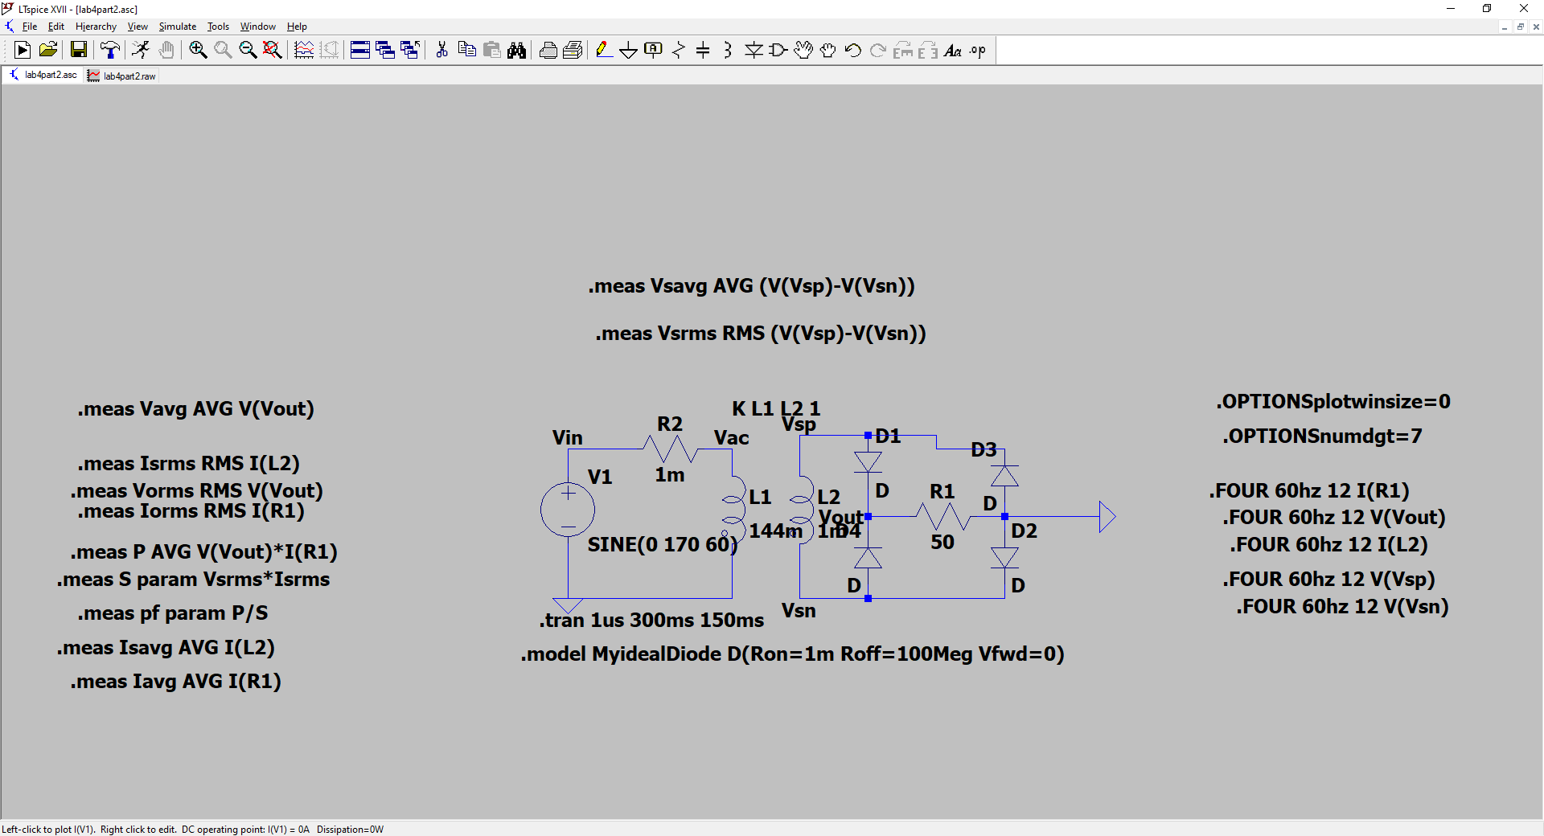

|  | Average | RMS | Peak | FFTDCValue | FFTn = 1 | FFTn = 2 | FFTn = 4 | FFTn = 6 | FFTn = 8 | FFTn = 10 | FFTn = 12 |
| --- | --- | --- | --- | --- | --- | --- | --- | --- | --- | --- | --- |
| OutputVoltage | 3.75584 | 6.57921 | 12.51 | 3.75536 | 7.054e+00 | 2.883e+00 | 5.070e-01 | 1.766e-01 | 7.290e-02 | 3.093e-02 | 1.237e-02 |
| LoadCurrent | -0.150243 | 0.171614 | 250e-03 | - | - | - | - | - | - | - | - |
| SourceVoltage | 6.58015 | 0.171613 | 14.10 | - | - | - | - | - | - | - | - |
| SourceCurrent | 5.4282e-005 | 0.171613 | 250 e-03 | - | - | - | - | - | - | - | - |

**Output voltage**

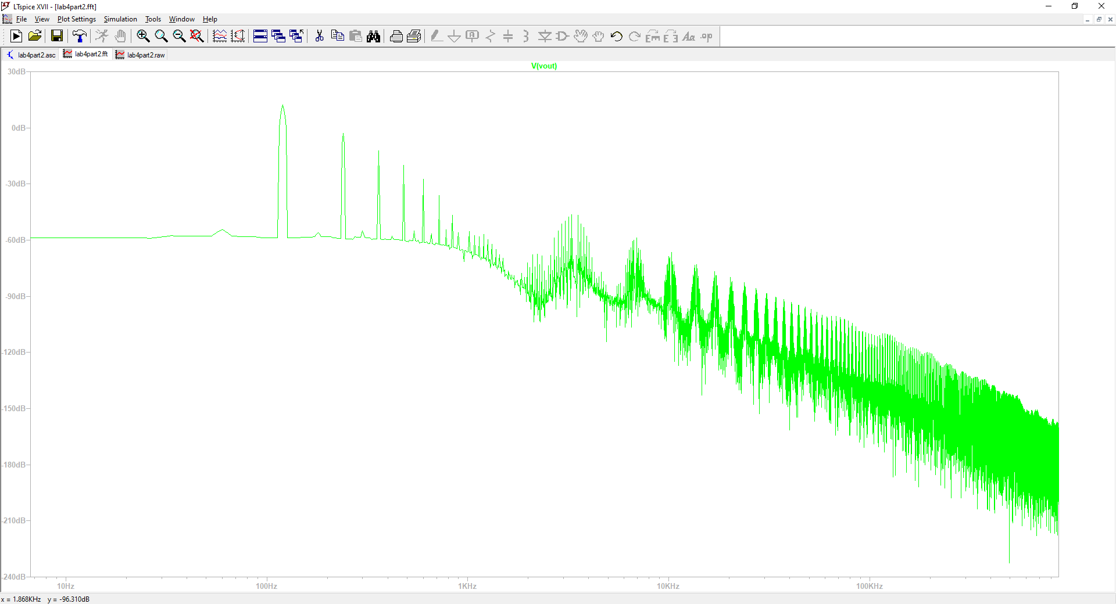

**Output Current**

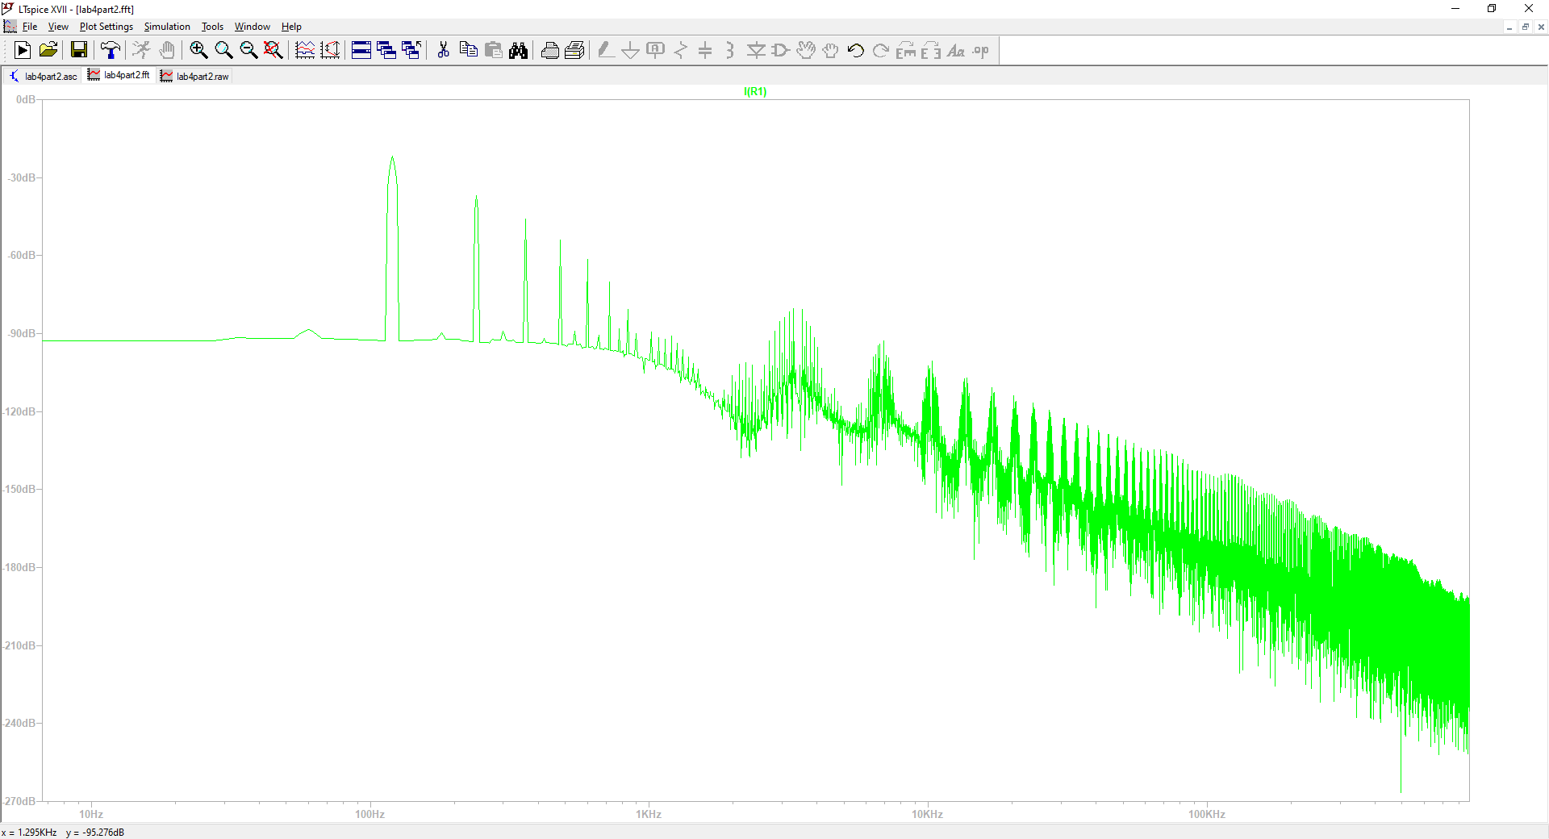

Questions

* How does the average output voltage compare to the half wave rectifier?
  + The average output voltage for the single phase rectifier contributes all of the voltage signal expressed at the input into the output. No signal is lost, compared to that of the half wave, in which some signal is lost at the output.
* How does the power factor compare to the half wave rectifier?
  + In ideal circumstances, the power factor for a single phase rectifier is 1. This is a major improvement compared to that of the half wave rectifier. In ideal circumstances, the maximum possible power factor for a half wave rectifier is 0.707.
* What do you observe about the harmonics?
  + There is a major harmonic component at DC, and then several, smaller peaks can be observed after the DC plot.

**Part 3: Three-Phase Rectifier**

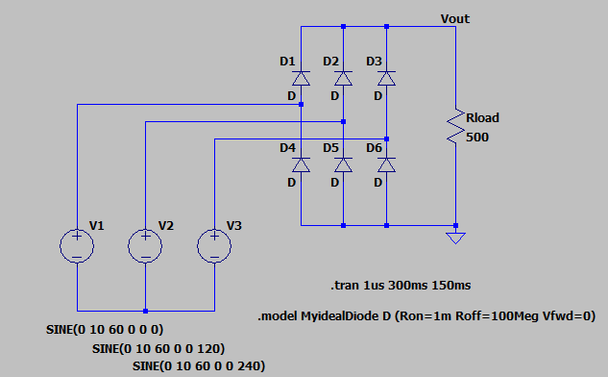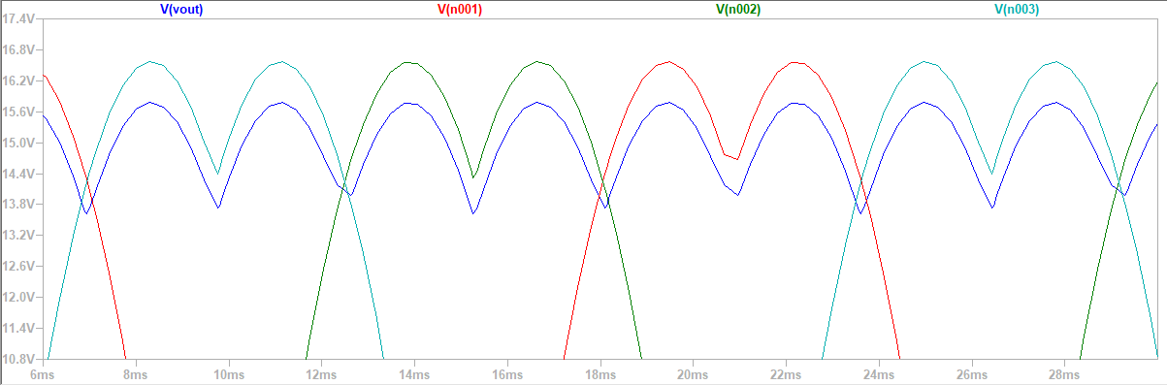

* 1. Output Voltage Average = 15.0211V
  2. Load Current Average = 0.0300421A

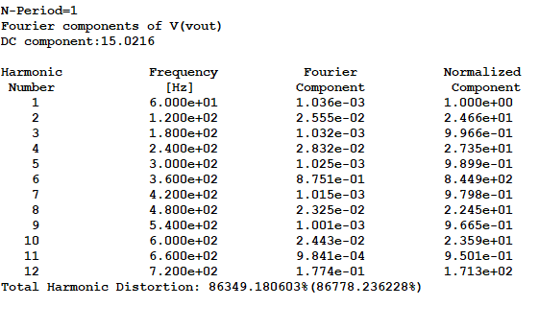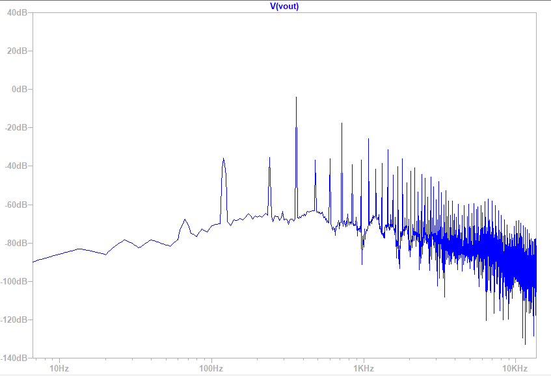

**Observations:**

We can see how as frequency increases it begins to switch faster and faster which is why we have a bunch of data at the end. We also see how at around 550Hz it appears as if the peak reaches 0dB.

**Part 4: Physical Build**

This will make our calculations differ because we have been getting them assuming an ideal diode. With the physical build obviously the diode won’t be ideal, which will change our measurements.

**Rectified Output**

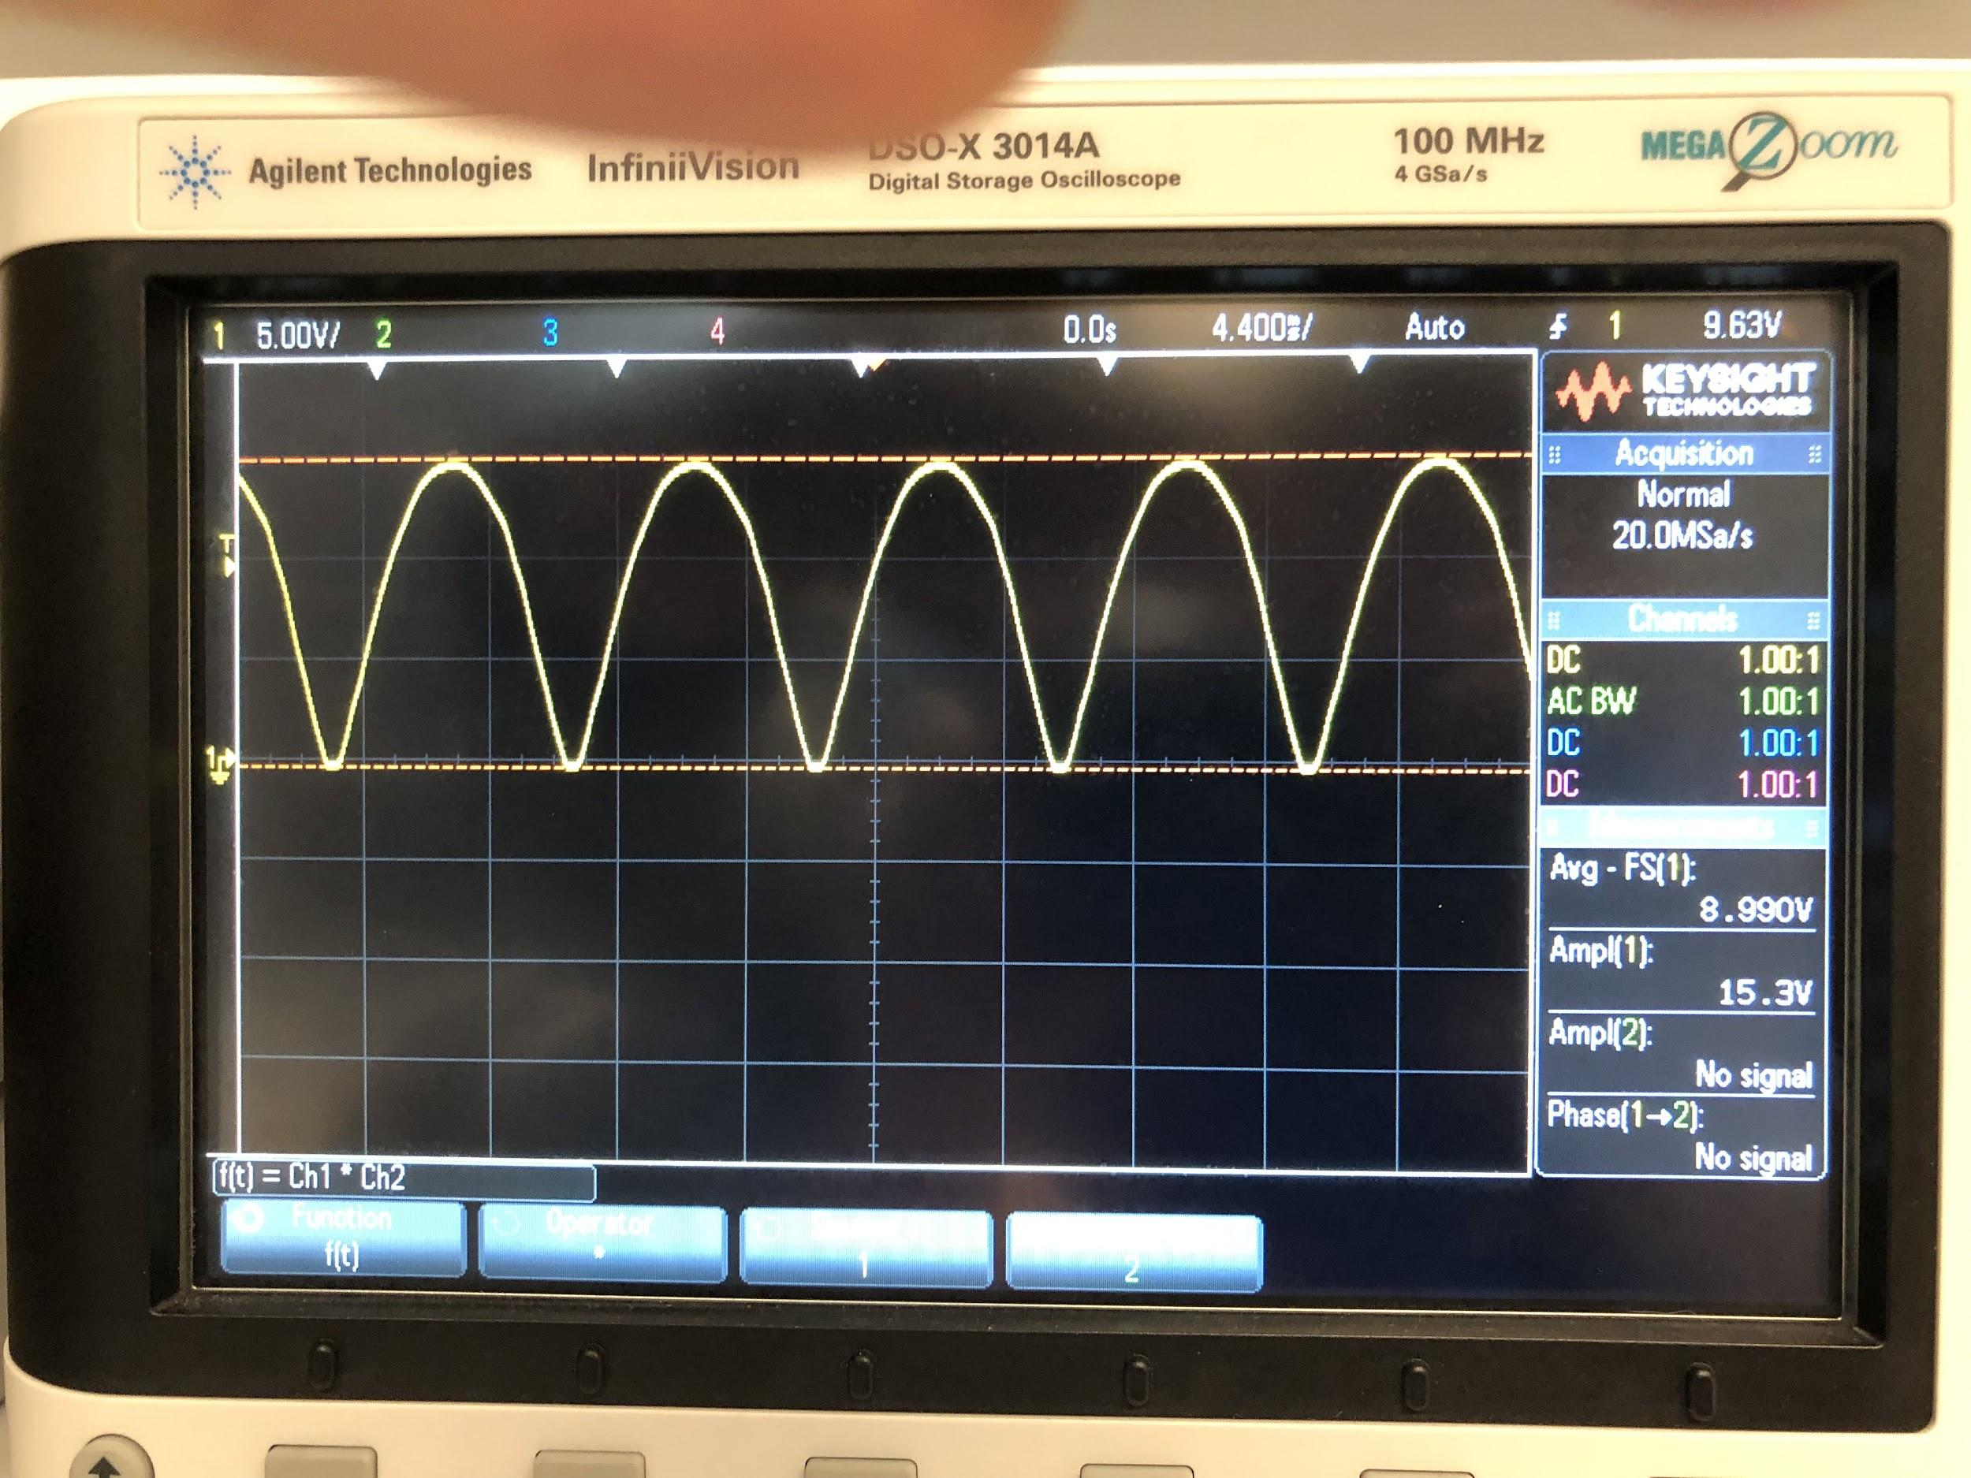

**Rectified Output AC RMS**

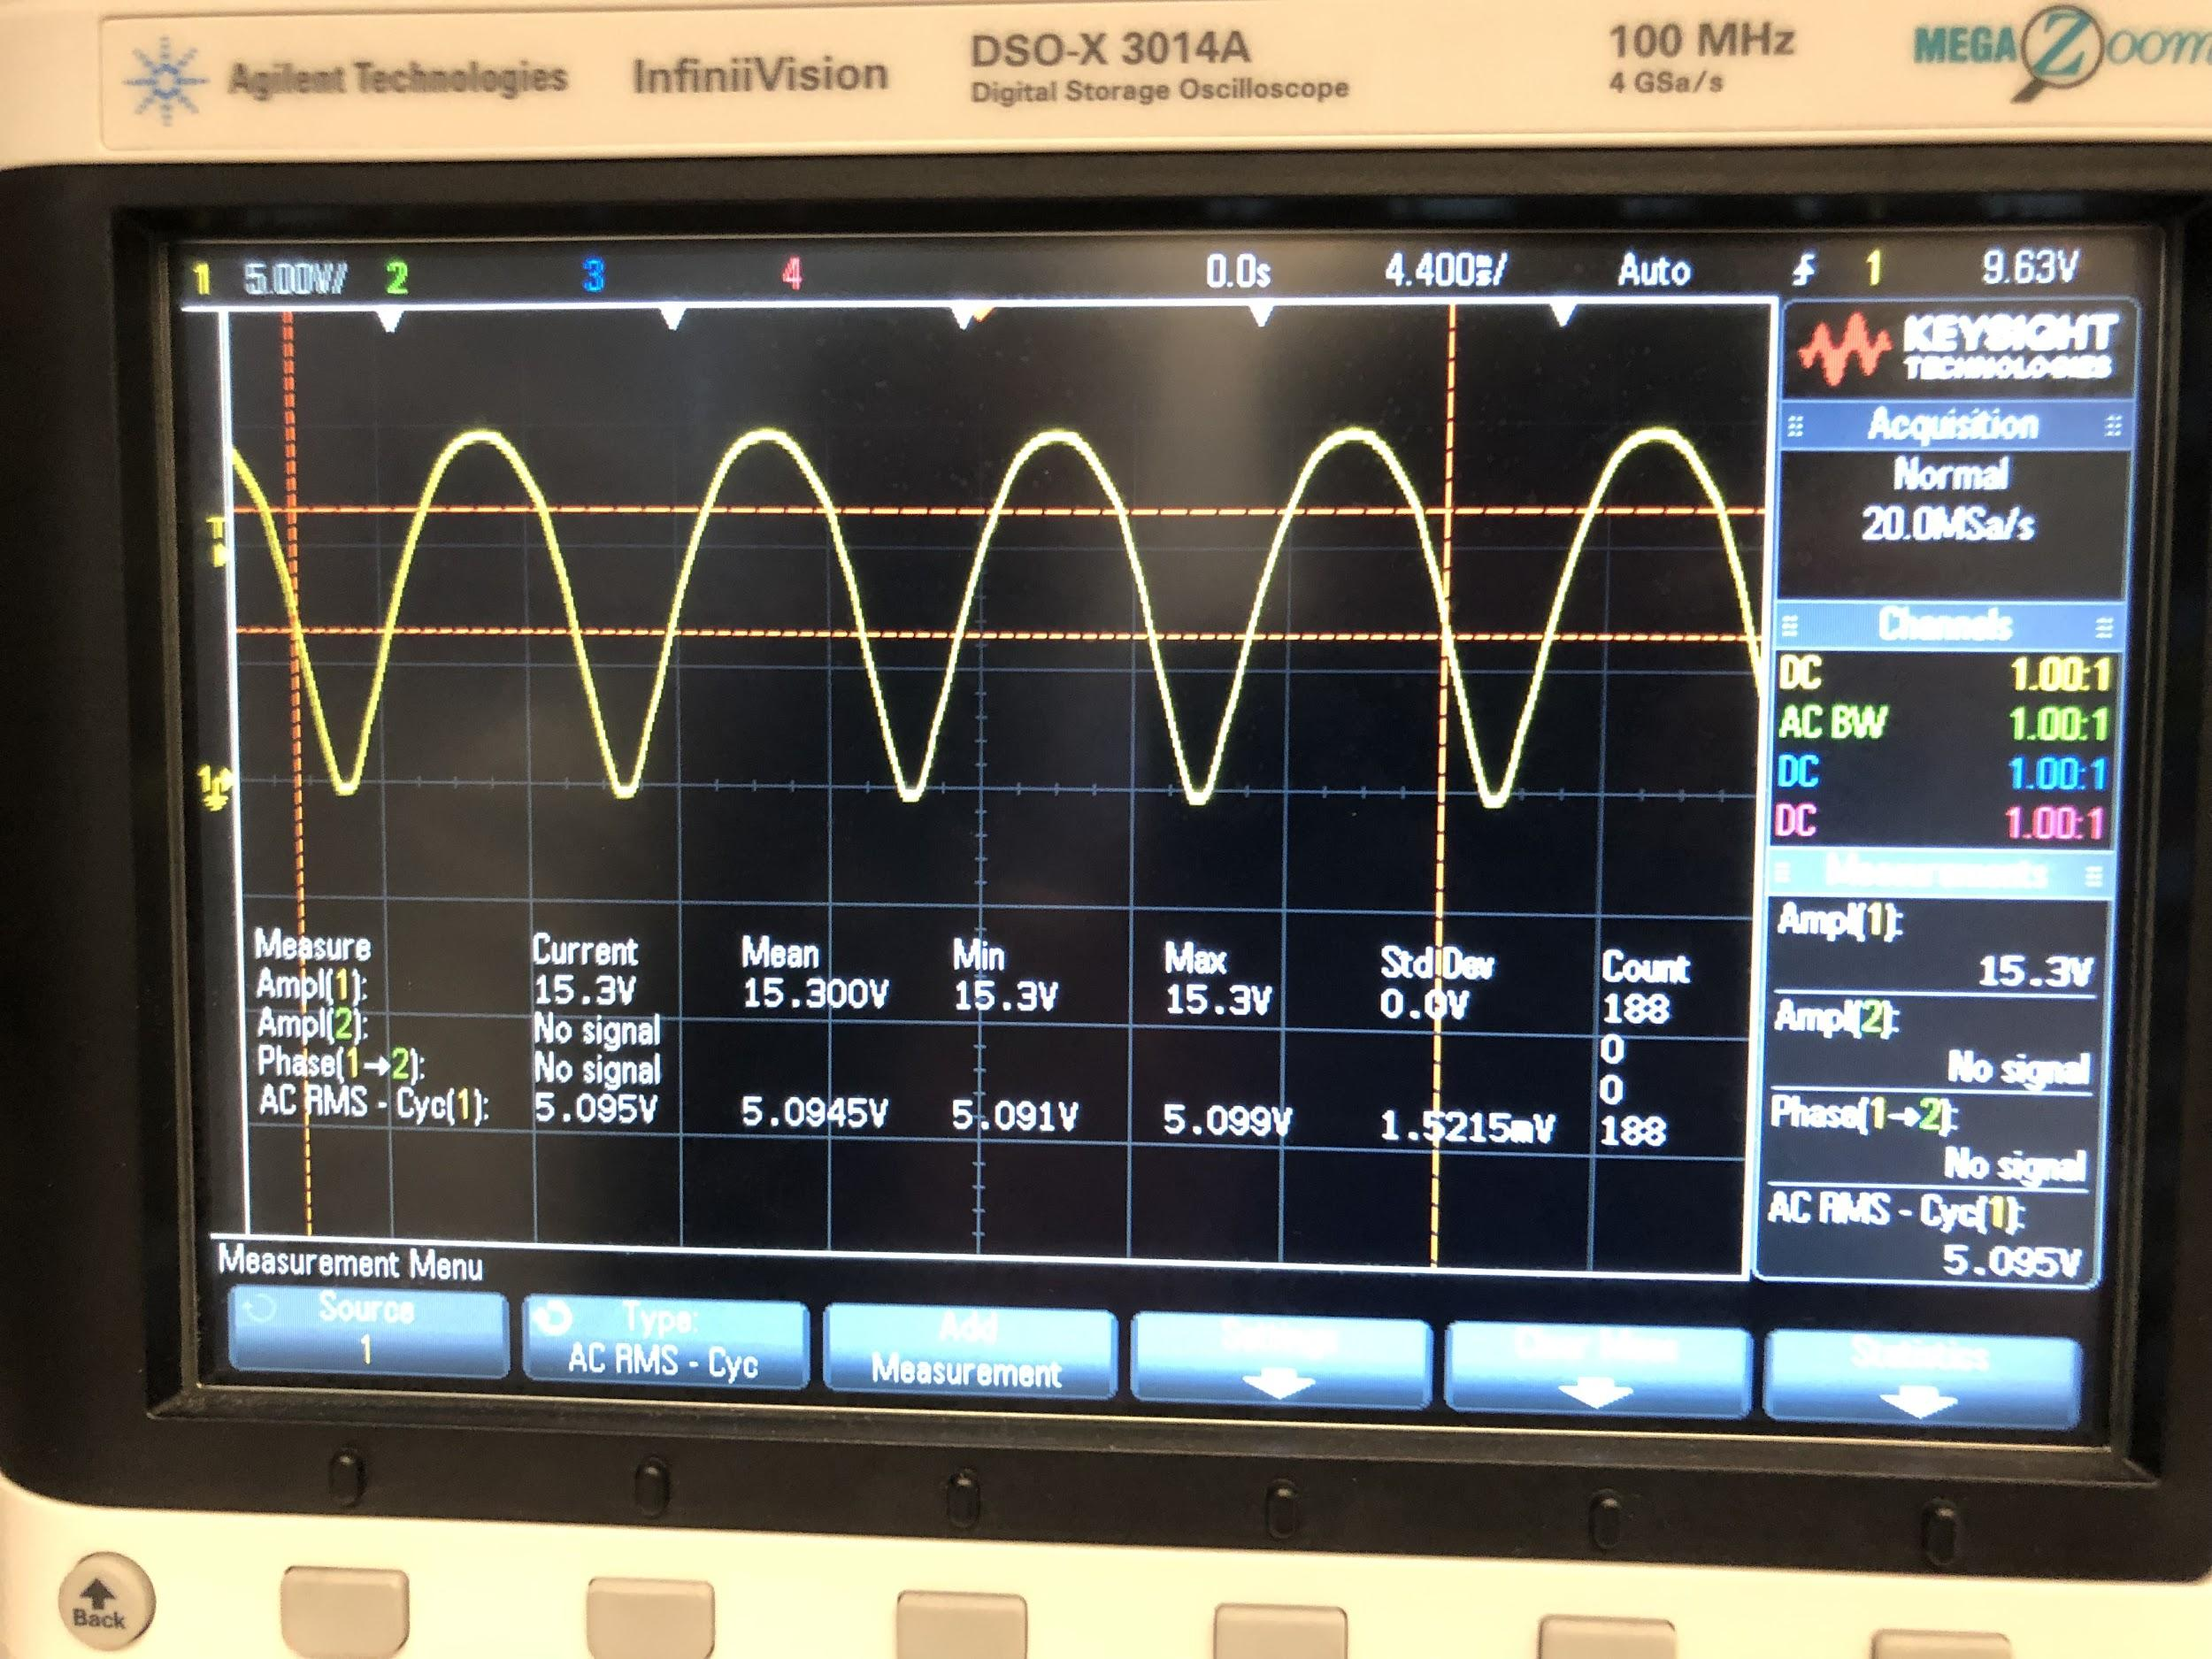

**Rectified Output AC FFT**

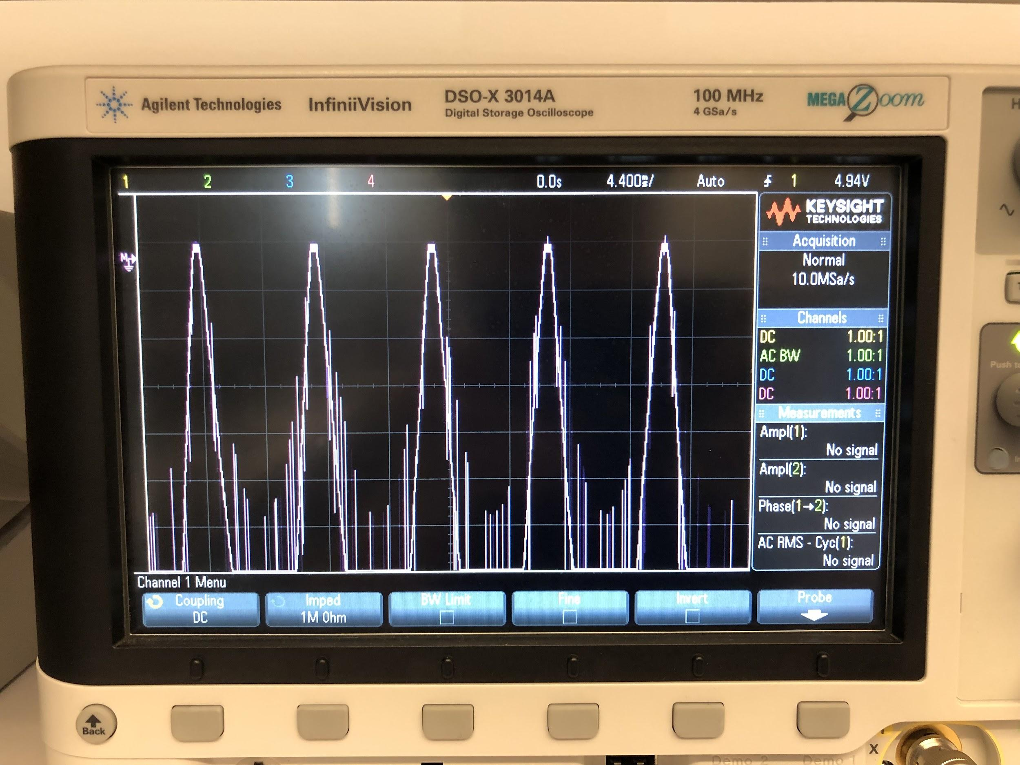

**Rectified Output AC FFT (Clearer Waveform)**

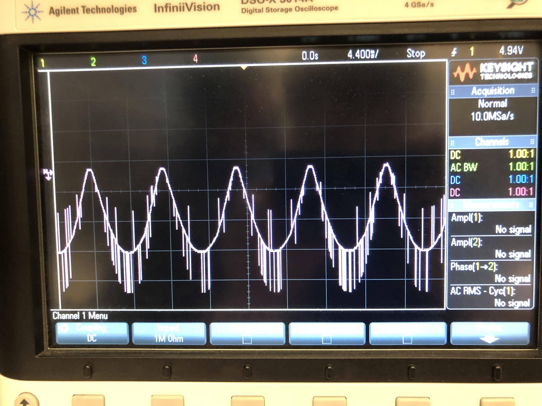

**Objective:**

The objective of this lab was to explore the different types of rectifiers and see what kind of output they would give us. Then we tested different filters and options for improving those outputs even more. This is important because it will allow us to get the best efficiency out of our circuits.

A single phase rectifier has the least stringent requirements because of the output that it naturally produces. It is easier to filter out because the values have a smaller range.